## Architecture Sketch (I will update it on Friday, or alternatively we could meet again)

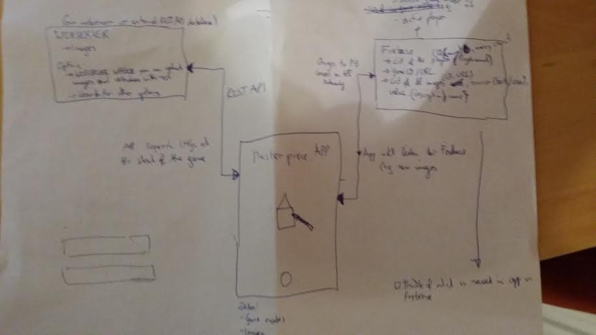

Webserver:

* stores images
* options
  + webserver where you can upload images and retrieve via REST API
  + search for other options (e.g. REST API Image services like google but more specific to artwork or other things)

Masterpiece Application

* stores game modes and the overall game logic
* stores images (part of the model)
* listens to firebase
* requests information from webserver
* updates firebase

Firebase Server:

* List of all the players (ID, name, money count)
* General information on the game: active game mode, active player, playercount
* GameID/URL
* List of all images (ID, URL), owner (e.g. bank, player), value, name

## Screen Flow

A. Screen (Start Screen)

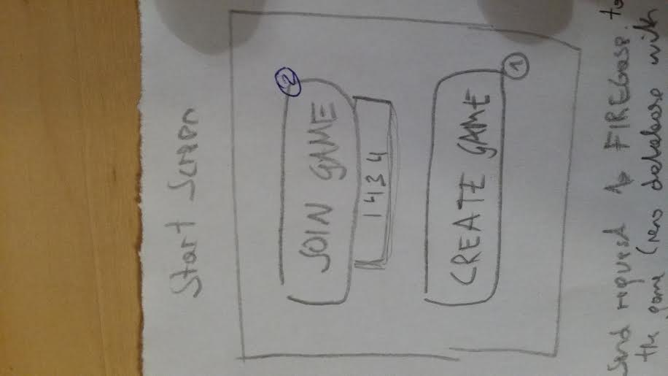

1. Send request to Firebase to create the game (new database with url) and unique game ID
2. Checking if Firebase database/url with the entered game ID exists, if yes, then

increment a player count

ask for the name via a popup (username)

set in the app that it listens to firebase

B. Game Lobby “Waiting for Players”

* shows the game ID, the number and names of the joined players, when 3 players have joined the option to START the game becomes available

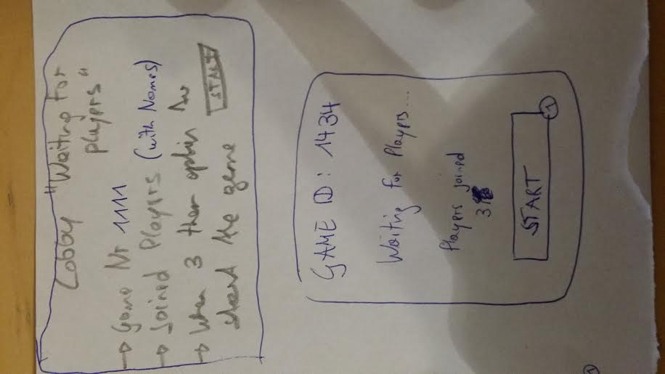

C. Pressing the START Button on Screen B

* App of User who created the game requests images from the images webserver via REST API
* App of User who created the game updates the list in firebase with the image urls and sets up the initial game parameters (e.g. random values for paintings, assign each player one painting,...)
* All devices/connected players are updated with the images / initial game state (e.g. money, paintings etc.)
* Assign starting player (random)

D. List of views/screens for active game

1. Overview
   1. Fixed
      1. Player owned images with value of each painting
      2. Player money
   2. Dynamic
      1. Opponents with paintings (no value)
      2. Status (e.g. “Geoffs turn”)
2. Bank Auction
   1. Picture of auctioned item (random painting)
   2. Current bid
   3. Button/Interaction to bid (e.g. swiping)
   4. (Timer - not for now)
   5. Button for “Don’t bid” or “Stop bidding”
   6. Screen: You bought this item (after buying) - item, final bid, real value)
3. Roll/Shake View (“Shake phone to select game mode”)
4. Private Auction → similar to Bank Auction except initial screen to select the paintings which should be auctioned (ensure that the auctioning player cannot bid)
5. Sell to bank for price X
   1. Choose 1 of the paintings you own
   2. Sold screen

E. End of game screen

* Show ranking of player with the final money/wealth
* (Future/not for now: Play again feature)
* Home button to go back to the start

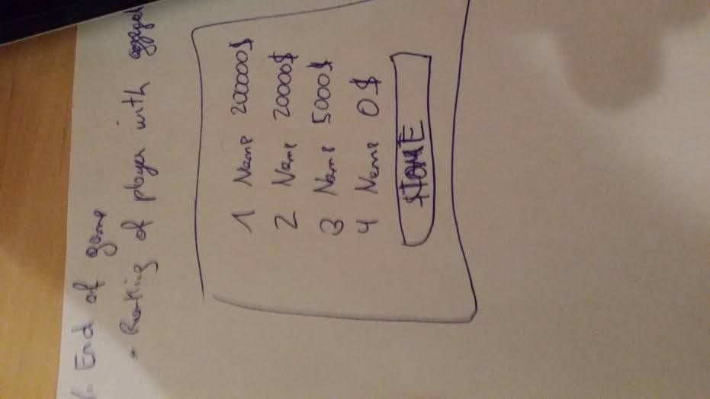

## List of potential enhancements

* Sending requests to other people who also have the game (e.g. friends)
* Pre-defining the player count when creating the game
* Characters
  + Special powers e.g. priority of purchasing, charm, discounts, more starting money
  + Pictures + descriptions
* Eventually need a guaranteed unique id for your game (need to avoid to randomly select someone elses game)
* Timer for auctioning (if we want it)
* Play again functionality